Workflow
VB Approval:
Transaction (Vendor Bill)
Description
VB Approval workflow: All vendor bills are divided into 4 categories:
- Perfect Match: If PO=IR=VB then vendor bill will be auto approved
- 2 Way: If PO not = VB then DR/DH approvals are required
- 3 Way: If PO not = IR and VB then DR/DH approvals are required
- Standalone: Will go through all approval levels.
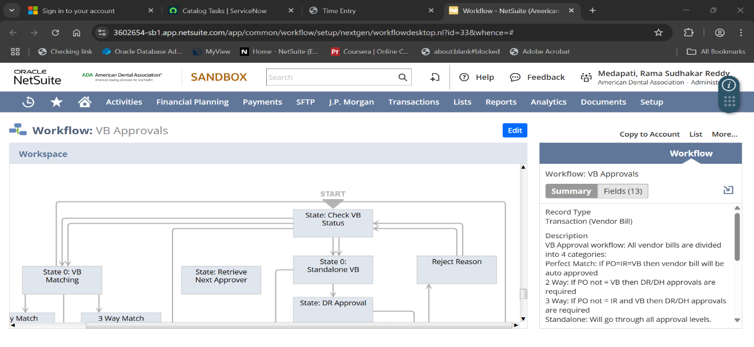

Then Go to Start State: Check VB Status
There are almost 25 Actions to perform in this state:
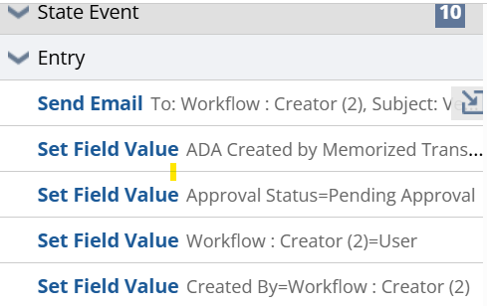
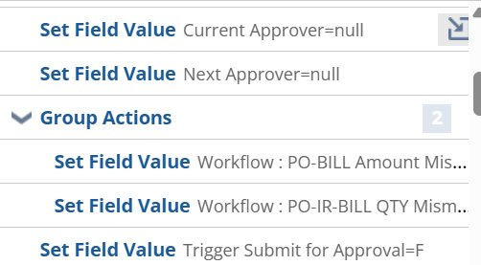
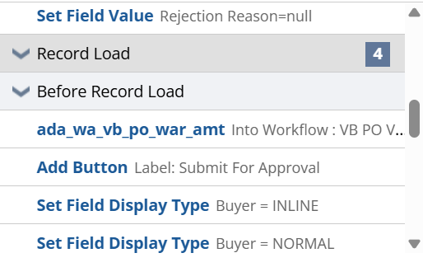
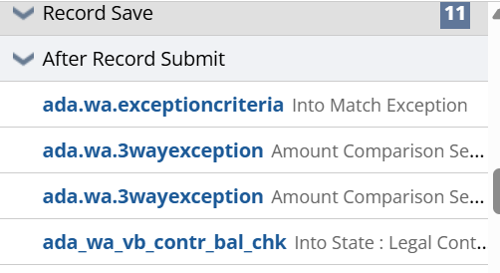
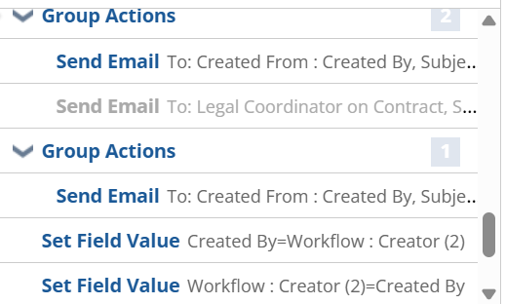
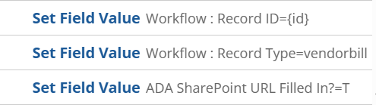
Let start from initial state:
There are performing initially Entry of the state:
- Send Email:
- If Created by Is Not Empty and Workflow: Creator (2) Is Not Empty and Approval Status = Rejected they are sending an email.
- Set Field Value:
- If context type is Payment Post back and User Event, they enabling the ADA Created by Memorized Transaction=T.
- Set Field Value:
- If Approval Status! = Rejected they are setting the value to Approval Status = Pending Approval.
- Set Field Value:
- If Workflow: Creator (2) Is Empty they are setting current user to Workflow: Creator (2) =User
- Set Field Value:
- If Created By Is Empty they are setting the workflow creator to the Created By=Workflow: Creator (2)
- Set Field Value:
- In Sub list items they are setting Current Approver = Null.
- Set Field Value:
- In Sub list items they are setting Next Approver = Null.
They are Performing group of actions in state:
- Set Field Value:
- If Po bill amount mismatch they are enabling the checkbox to true Workflow: PO-BILL Amount Mismatch=T.
- Set Field Value:
- If Po IR amount mismatch they are enabling the checkbox to true Workflow: PO-IR Amount Mismatch=T.
- Set Field Value:
- In Sublist items they are setting Trigger Submit for Approval=F.
- Set Field Value:
- If Approval Status! = Rejected we need to set Rejection Reason=null.
In record load they are performing some operations:
- WorkFlow Action Script:
- ada_wa_vb_po_war_amt :
- If Vendor bill po amount more than $10,000 and return result in workflow parameter and pass then result to workflow parameter to used in Submit in Approval.
- Add Button:(Submit for Approval)
- If {userrole.id} in(3,1164,1439)AND ({custbody_match_exception.id}=3 or ({createdfrom.statusref.id} not in ('closed','pendingSupApproval','rejectedBySup')and {statusref} not in ('Cancelled','Open','Paid In Full')and (({custbody_non_contract_purchase.id}='T' and ({custbody_effective_amount} BETWEEN 0 AND ({createdfrom.custbody_ada_po_rem_bal}+9999)))or ({custbody_non_contract_purchase.id}='F' and {custbody_contract.id} is not null and {custbody_match_exception.id} in (1,2)and{custworkflow_ada_vb_po_valid} = 1))))AND (({custbody_ada_vendor_bill_sp_url} is not null and {custbody_ada_kc_url_filled_in.id} = 'T') or {entity.id} in ('4386') or {subsidiary.id} in (10) or {custbody_ada_created_by_memorized_tran.id}='T').
- Set Field Value:
- If Created from Is Not Empty they are setting value to within the Inline Buyer = INLINE.
- Set Field Value:
- If Created from Is Not Empty they are setting value to within the Inline Buyer = NORMAL.
In record save they are performing some workflows:
WorkFlow Action Scripts:
- ada.wa.exceptioncriteria:
- In this exception criteria they are checking ‘2 Way’, ‘3 way’ and ‘standlone’.
- They are loading the record and checking the conditions poline <=0 its standalone and pushing all the items into one array and checking item type if its service item return ‘2 way’.
- Otherwise, its return ‘3 way’. And store the result in Match Exception.
- ada.wa.3wayexception:( PO-BILL Amount Mismatch)
- If its check the condition is Match Exception = 3 they created saved search Amt Comparison (Used by Script- Do not change/delete) and checking the quantity and amount in switch condition if its doesn’t match by default checkbox to true and based on search result its return True or else false.
- They are using one library file on above script ada.vendorbill.wf.util.js they are passing script and search id its return the name of that parameter.
- ada.wa.3wayexception:( PO-IR-BILL QTY Mismatch)
- If its check the condition is Match Exception = 3 they created saved search Amt Comparison (Used by Script- Do not change/delete) and checking the quantity and amount in switch condition if it’s doesn’t match by default checkbox to true and based on search result its return True or else false.
- They are using one library file on above script ada.vendorbill.wf.util.js they are passing script and search id its return the name of that parameter.
- ada_wa_vb_contr_bal_chk:
- It returns the available balance of the legal contract and stores it into the Workflow State field to be used in the Group 2 condition of the State.
They are Performing one group of actions in state:
- Send Email:
- If we Vendor Bill {tranid} for ${total} is more than the {createdfrom.tranid} amount and the {custbody_contract} amount has been exceeded, they sent an email to accountpayable and smithl.
- Send Email:
- If we Vendor Bill {tranid} for ${total} is more than $10,000 over the {createdfrom.tranid} amount.
- If Created From: Created By, Subject: Vendor Bill {tranid} for ${total} is more than the {createdfrom.tranid} amount and the {custbody_contract} amount has been exceeded.
They are Performing groups of actions in state:
- Send Email:
- Vendor Bill {tranid} for ${total} is more than $10,000 over the {createdfrom.tranid} amount.
- To: Created From: Created By, Subject: Vendor Bill {tranid} for ${total} is more than $10,000 over the {createdfrom.tranid} amount.
- Set Field Value:
- If ({user.id}! =-4) then we can set Created By=Workflow: Creator (2).
- Set Field Value:
- If ADA Created by Memorized Transaction = T then we can set to Workflow: Creator (2) =Created By.
- Set Field Value:
- In sublist items line it they are strong in Workflow: Record ID={id}.
- Set Field Value:
- In sublist items vendorbill text stored in Record Type (Workflow) field.
- Set Field Value:
- If ADA SharePoint URL Is Not Empty in line level items, they are enabling the checkbox in ADA SharePoint URL Filled In? = T.

